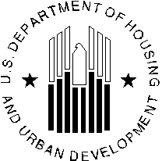
U.S. DEPARTMENT OF HOUSING AND URBAN DEVELOPMENT
WASHINGTON, DC 20410-5000

OFFICE OF PUBLIC AND INDIAN HOUSING

Special Attention of: NOTICE: PIH-2023-03(HA)

Public Housing Agencies Issued: March 13, 2023 Public Housing Hub Office Directors
Public Housing Program Center Directors Expires: Effective until amended, Regional Directors superseded, or rescinded
Field Office Directors and
Resident Management Corporations Cross References: 81 FR 85996, 83 FR 35490, PIH-2019-11(HA)

Subject: Supplemental Guidance for Implementation of Section 103; Limitation on Public Housing Tenancy for Over-Income Families under the Housing Opportunity Through Modernization Act of 2016 (HOTMA)

Table of Contents
- Purpose 2
- Background 2
- Applicability 4
- Key Terms 5
- Effective Date of Over-Income Limits and Integration into the Admissions and Continued Occupancy Policies (ACOP) 6
- Summary of Associated Regulatory Changes 7
- Implementing Over-Income Policies 9
  - Determination of the OI Limit 10
  - Notification Requirements 10
  - Limitation on public housing tenancy 12
  - End of the grace period and Status of an Over-Income Family 13
  - Reporting Requirements 15
- Determination of the Alternative Rent and the new lease for NPHOI families 16
- Unit Tenant Status Category and Sub-Category 17
- Repositioning 17
- Technical Assistance 18
- Paperwork Reduction Act 18
Appendix I – How to Process an Over-Income Family 19
Appendix II – Calculating the Over-Income Limit 21

Purpose
This notice supersedes Notice PIH-2019-11(HA) dated May 3, 2019. It provides guidance to Public Housing Agencies (PHAs) regarding the new limitations on continued occupancy in public housing for over-income families, as defined in the Housing Opportunity Through Modernization Act of 2016 (HOTMA) (Pub. L. 114-201, 130 Stat. 782). The final rule was published in the Federal Register (88 FR 9600) on February 14, 2023.

This notice restates the instructions on how a PHA must calculate the over-income limit (OI limit) for a family in the public housing program while providing new guidance on setting rents for over-income families allowed by PHA policy to remain in a public housing unit. This notice also addresses the effective dates in the final rule and what it means for families determined to be over-income prior to the final rule. Lastly, this notice describes the requirement to submit annual reports on the number of over-income families residing in public housing and on the number of families on PHA waiting lists for public housing projects.

Background
HOTMA was signed into law on July 29, 2016. Section 103 of HOTMA amends section 16(a) of the United States Housing Act of 1937 (42 U.S.C. 1437n(a)) (1937 Act) and establishes an income limitation for continued occupancy in public housing. The statute requires that after a family’s income has exceeded the over-income limit for two consecutive years or 24 consecutive months¹ (the “grace period”), a PHA must either terminate the family’s tenancy within six months or charge the family the alternative non-public housing rent (alternative rent). The alternative rent must equal the greater of: (1) the applicable Fair Market Rent (FMR); or (2) the amount of monthly subsidy provided for the unit. The per unit monthly subsidy includes amounts from the Operating and Capital Funds, as defined by the new regulations at 24 CFR 960.102.

Section 103 of HOTMA was partially implemented by the U.S. Department of Housing and Urban Development (HUD) in 2018,² however, there were several delays in the full implementation.³ As a result, guidance provided for the implementation of Section 103 of HOTMA is extensive and is anticipated to continue over the next several years. Below is a consolidated list of HUD’s Section 103 implementation and guidance documents to date:

  - 81 FR 85996 - Housing Opportunity Through Modernization Act of 2016: Solicitation of Comments on Implementation of Public Housing Income Limit (November 29, 2016).
    - This notice solicited public comment on the methodology HUD used to calculate the over-income limit. Specifically, comments were requested on whether the practice (multiplying the very low-income (VLI) limit by a factor of 2.4) adequately considered local housing costs and made appropriate adjustments to the over-income limit. This method to determine the over-income limit has been codified in the HOTMA final rule.

¹ 24 CFR 960.507(a)
² 83 FR 35490
³ Due to the unprecedented challenge of the COVID-19 pandemic and the authority provided under the Coronavirus Aid, Relief and Economic Security (CARES) Act (Public Law 116-136), HUD elected to waive and establish alternative requirements for numerous statutory and regulatory requirements for the Public Housing program.

  - 83 FR 35490 - Housing Opportunity Through Modernization Act of 2016: Final Implementation of Public Housing Income Limit (July 26, 2018). (2018 FR Notice)
    - This notice required PHAs to implement an over-income limit in their public housing program no later than 6 months after the September 24, 2018, effective date of the notice (by March 24, 2019).

  - Notice PIH 2019-11 - Final Implementation of Public Housing Over-Income Limit under the Housing Opportunity Through Modernization Act of 2016 (HOTMA). (May 3, 2019)
    - This notice provided guidance and examples on how a PHA should begin to implement an over-income limit in their public housing program. It also announced that the authority to charge the alternative rent would only be made effective by rulemaking.

  - 84 FR 48820 – Proposed Rule: Housing Opportunity Through Modernization Act of 2016: Implementation of Sections 102, 103, and 104. (September 17, 2019)
    - The proposed rule provided the suggested regulations on the implementation of the over-income limit.

  - Notice PIH 2020-05 - COVID-19 Statutory and Regulatory Waivers for the Public Housing, Housing Choice Voucher, Indian Housing Block Grant and Indian Community Development Block Grant programs, Suspension of Public Housing Assessment System and Section Eight Management Assessment Program. (April 10, 2020)
    - Authorized under the CARES Act, this notice delayed the full implementation of Section 103 of HOTMA by re-defining the two-year grace period as two consecutive reexamination cycles. If adopted, the waivers PH and HCV-2 and PH-7 would have resulted in an extended grace period for families determined to be over-income. The period of availability ended on December 31, 2020.

  - Notice PIH 2020-13 (HA) REV-1 - COVID-19 Statutory and Regulatory Waivers and Alternative Requirements for the Public Housing, Housing Choice Voucher, Indian Housing Block Grant and Indian Community Development Block Grant programs, Suspension of Public Housing Assessment System and Section Eight Management Assessment Program, Revision 1. (July 2, 2020)
    - This notice reiterated the alternative requirements given in Notice PIH 2020-05. The period of availability ended on December 31, 2020.

  - Notice PIH 2020-33(HA) REV-2 - COVID-19 Statutory and Regulatory Waivers and Alternative Requirements for the Public Housing, Housing Choice Voucher (including Mainstream and Mod Rehab), Indian Housing Block Grant and Indian Community Development Block Grant programs, Suspension of Public Housing Assessment System and Section Eight Management Assessment Program, Revision 2. (November 30, 2020)
    - This notice added waiver PH-13 which temporarily waived the termination requirement for an over-income family. As the final rule was not yet complete, this waiver also permitted PHAs to charge over-income families the applicable FMR as the alternative rent. The period of availability ended on June 30, 2021.

  - 85 FR 78295 - Proposed Rule: Housing Opportunity Through Modernization Act of 2016: Re-Opening Public Comment Period on Subject of Over Income Families (December 4, 2020). (2020 FR Notice)
    - HUD issued this notice to seek additional public comment on the implementation of the public housing over-income limit, specifically on a PHAs' discretion in addressing over-income families. These comments were used to inform the development of the final rule.

  - Notice PIH 2021-14 (HA) - COVID-19 Statutory and Regulatory Waivers and Alternative Requirements for the Public Housing, Housing Choice Voucher (including Mainstream and Mod Rehab), Indian Housing Block Grant and Indian Community Development Block Grant programs, Suspension of Public Housing Assessment System and Section Eight Management Assessment Program, Revision 3. (May 4, 2021)
    - This notice reiterated the alternative requirements permitted in Notice PIH 2020- 33 and extended the period of availability. The period of availability ended on December 31, 2021.

  - Frequently Asked Questions (FAQs): Implementing the Housing Opportunity Through Modernization Act (HOTMA) Public Housing Income Limit. (January 28, 2022). (https://www.hud.gov/sites/dfiles/PIH/documents/HOTMA%20Public%20Housing%20I ncome%20Limit.pdf)
    - This FAQ was published to address the gap in guidance left by the expiration of the CARES Act authority to charge over-income families the FMR as the alternative rent. The guidance confirmed that a PHA may elect to terminate over- income families who exceed the over-income limit for two consecutive years, but they were not required to do so. If a PHA elected not to terminate over-income families who exceed the grace period, then the PHA was required to offer the families the option once again of paying an income-based rent or a flat rent at their next annual reexamination. HUD confirmed that it would not enforce the requirement to charge the alternative rent until HUD published the final rule.

  - 88 FR 9600 - Housing Opportunity Through Modernization Act of 2016: Implementation of Sections 102, 103, and 104 (February 14, 2023). (HOTMA final rule)
    - With the publication of the final rule, all elements of Section 103 of HOTMA will become effective after 30 days, i.e., March 16, 2023. The HOTMA final rule requires all PHAs to fully implement the OI requirements by June 14, 2023.

Applicability
Section 103 of HOTMA applies to all PHAs operating a public housing program, including Moving to Work (MTW) Agencies. However, a PHA that owns or operates fewer than 250 public housing units may continue to lease public housing units to non-assisted over-income families in accordance with Section 3(a)(5) of the 1937 Act and 24 CFR 960.503. The over- income limit does not apply to these unassisted families whose annual income exceeds the applicable low-income limit at the time of initial occupancy.

There are no exceptions to the limitation on public housing tenancy for HUD assisted tenants who are determined to be over-income for 24 consecutive months. However, a modification to the limitation has been made for MTW agencies. The MTW Operations Notice (85 FR 53444) extends the 2-year grace period to 3 years, and allows MTW PHAs to request a waiver, which must be approved by HUD, to extend the grace period further.

Key Terms
ACOP refers to the Admissions and Continued Occupancy Policies (ACOP) for the Public Housing Program.
Alternative non-public housing rent (alternative rent) is the monthly amount a PHA must charge non-public housing over-income (NPHOI) families, if allowed by PHA policy to remain in a public housing unit, after they have exceeded the 24 consecutive month grace period. The alternative rent is defined at 24 CFR 960.102, as the higher of the Fair Market Rent (FMR) or per unit monthly subsidy. The monthly subsidy provided for the unit, is determined by adding the per unit assistance provided to a public housing property as calculated through the applicable formulas for the Public Housing Capital Fund and Public Housing Operating Fund. See 24 CFR
960.102 for more details about how HUD will calculate and publish such funding amounts.

Non-public housing over-income family (NPHOI family) is defined in 24 CFR 960.102 as a family that has exceeded the over-income limit for 24 consecutive months who remains in a public housing unit, as allowed by PHA policy, paying the alternative rent. These families are no longer public housing program participants and are unassisted tenants.

Over-income family (OI family) is defined in 24 CFR 960.102 as a family whose income exceeds the OI limit. This term includes families during the grace period or that are in the period before termination and are still public housing program participants. Note that in the public housing program, this term previously referred to a family that is not a low-income family (i.e., a family with an income exceeding 80 percent Area Median Income (AMI)).

Over-income limit (OI limit) is defined in 24 CFR 960.102. In the regulations, this amount is determined by multiplying the applicable income limit for a very low-income (VLI) family, as defined in 24 CFR 5.603(b), by a factor of 2.4 (i.e., 120 percent of the AMI). See section 7 of this notice for further information.
PHA Plan is defined in 24 CFR 903.4(a). It is a comprehensive guide to the public housing agency’s policies, programs, operations, and strategies for meeting local housing needs and goals. There are two parts to the PHA Plan: the 5-Year Plan, which each PHA submits to HUD once every 5th PHA fiscal year, and the Annual Plan, which is submitted to HUD every year by non-qualified agencies (non-qualified agencies are PHAs that do not meet the definition of a qualified agency).⁴

⁴ A qualified PHA is a PHA with 550 or fewer public housing dwelling units and/or housing choice vouchers combined and is not PHAS or SEMAP troubled.

Effective Date of Over-Income Limits and Integration into the Admissions and Continued Occupancy Policies (ACOP)
Per the 2018 FR notice, all PHAs were required to update their ACOP to implement the public housing OI limit. The earliest date a PHA could begin to implement their over-income policy (OI Policy) would have been September 24, 2018. However, if implementation of this provision required a significant amendment, the PHA was required to complete all relevant PHA Plan and ACOP changes no later than 6 months after the applicable date of the 2018 FR notice. All OI polices were to include the imposition of the over-income limit in the program, when the 24 consecutive month grace period begins, and the notification requirements.
Any income reexaminations that took place after completion of the PHAs’ OI policy amendment was to apply the applicable OI limit. Notice PIH 2019-11 clarified that a family would be determined to be OI at an interim or annual reexamination. Once adopted, PHAs were to update the OI limits for the public housing program in their ACOPs no later than 60 days after HUD publishes new income limits each year.⁵

CARES Act impact on OI Policy Implementation

Due to the various CARES Act waivers discussed above, it is possible that a family determined to be over-income as of September 24, 2018, or later, would have had their second or final income reexamination delayed until December 31, 2020, (per PIH 2020-33) or later (per PIH 2021-14). Depending on PHA policy, the tenancy of an OI family could have been terminated, at the earliest, by June 30, 2021, or the family could have been required by the PHA to pay the applicable FMR for their unit beginning January 1, 2021, and ending December 31, 2021. If a PHA chose not to adopt these CARES Act waivers, the only option available to the PHA would have been to terminate the tenancy of the family within 6 months of the end of the grace period. PHAs should be aware that with the publication of the final rule, OI families that have completed the 24 consecutive month grace period or two consecutive reexamination cycles under the existing notification requirements do not get a new grace period.

The Section 103 requirements of the HOTMA final rule, specifically 24 CFR 960.507, 960.509 and the relevant regulations discussed in part 6 of this notice, will become effective 30-days after publication. At that time, the PHA should begin to implement their over-income policy after revising their ACOP if a significant amendment is not required. If the implementation of this provision requires a significant amendment to the PHA Plan, a PHA should immediately take steps to complete the significant amendment process to effectuate the policy change in their PHA Plan and ACOP no later than 120 days after the effective date of the over-income provisions of the HOTMA final rule. Specifically, this means that the OI family’s tenancy and participation in the public housing program must end within six month of the final over-income determination and if the PHA policy permits the family to remain in a public housing unit, the family must be charged the alternative rent upon the completion of the grace period.

⁵ https://www.huduser.gov/portal/datasets/il.html

All over-income requirements, specifically 24 CFR 960.507, 960.509 and the relevant regulations discussed in part 6 of this notice, are now effective as of March, 16, 2023 and are to be fully implemented by June 14, 2023.

Summary of Associated Regulatory Changes
The HOTMA final rule includes the new over-income requirements and makes necessary conforming changes to existing regulation including the removal of 24 CFR 960.261. The final rule updated existing requirements in 24 CFR 5.520, 5.628, 960.102, 960.206, 960.253, 960.601, 964.125, and 966.4. All regulatory changes are summarized below in numerical order (except for the parts containing definitions). Parts 960.507, and 960.509 are new regulations specific to the implementation of the over-income requirements and will be discussed in section 7 of this notice.

24 CFR 5.520 - Restrictions on assistance to Noncitizens
A conforming change was made to paragraph (d)(1) of this section to clarify that a PHA must provide prorated assistance to mixed immigration status families, except as provided in 24 CFR
960.507. Once a mixed family has exceeded the over-income limit for 24 consecutive months, the family will either have their tenancy terminated or they must pay the alternative rent as an NPHOI family. For a PHA with a termination policy for over-income families, mixed families will pay their current, prorated rent amount during the 6-month period before termination. If the mixed family is permitted to pay the alternative rent then, pursuant to 24 CFR 5.520(d)(1), the mixed family must not receive prorated assistance. Instead, the family must pay the full alternative rent amount.

24 CFR 5.628 - Family Payment
A new sub-paragraph was added at 24 CFR 5.628(a)(5) clarifying that the options available under the total tenant payment (TTP) now include the alternative rent (as defined in 960.102) for NPHOI housing families.

24 CFR 960.102 and 24 CFR 960.601 - Definitions
Additional definitions and clarifications were added to these sections to implement the new requirements found at 24 CFR 960.507 for families exceeding the over-income limit. These changes create new definition in 24 CFR 960.102 for the following terms: alternative non-public housing rent (alternative rent), non-public housing over-income family (NPHOI family), over- income family (OI family) and over-income limit (OI limit) defined above. PHAs should reference the definition of alternative rent for guidelines on how to set the rent for NPHOI families.

In 24 CFR 960.601, the definition of exempt individual was updated to clarify that members of an NPHOI family do not have to comply with the Community Service Activities or Self- Sufficiency Work Activities requirements (CSSR).

24 CFR 960.206 - Waiting list: Local preferences in admission to public housing program
This change creates a new local preference option for PHA admission. The PHA may choose to adopt this preference for NPHOI families who become a low-income family as defined in 24 CFR 5.603(b) and are eligible for re-admission to the public housing program. A PHA whose

policy is to terminate OI families after the 24 consecutive month grace period may not use this preference because this preference may not be applied to current public housing families or OI families who have vacated the public housing project.

24 CFR 960.253 - Choice of Rent- Rent Options
Conforming changes have been made to paragraphs (a) and (f) of this section to clarify the choice of rent in relation to NPHOI families and the new requirements found at 960.507. Families subject to 960.507 must pay the alternative rent, as stated in 960.253(a), when they've exceeded the grace period and allowed by PHA policy the option of remaining in a public housing unit. During the 24 consecutive month grace period, and in the 6 months before termination, the family will continue to pay their current rent choice amount (i.e., the family’s choice of income-based or flat rent, or the prorated rent for mixed families).

A conforming change has been made to paragraph (f) to clarify the exemption to the current practice of conducting a reexamination of family income every three years for a family that chooses the flat rent option. The PHA must no longer apply the three-year reexamination provision to families once the PHA determines that the family is over-income. Once a PHA determines the family is over-income, the PHA must follow the documentation and notification requirements under 960.507(c).

PHAs have no discretion when it comes to the rent for NPHOI families. Once the grace period ends, and if the family is given the option to remain in a public housing unit and they choose to remain, then the family is required to pay the alternative rent as determined in accordance with 24 CFR 960.102. NPHOI families must not be given the choice of flat rent, income-based or prorated-rent.

24 CFR 960.257 - Family income and composition: Annual and interim reexaminations The final rule clarifies in 24 CFR 960.257(a)(5) that NPHOI families cannot be subject to
income reexaminations. Additionally, 24 CFR 960.257(b)(4) states that, for over-income families in the period after the end of the 24 consecutive month grace period but before their tenancy termination pursuant to 24 CFR 960.507(d)(2), the PHA must conduct an interim reexamination of family income as otherwise required under 24 CFR 960.257. However, the resulting income determination will not make the family eligible to remain in the public housing program beyond the period before termination as defined by PHA policy. For over-income families who are in their grace period, 24 CFR 960.257 and 24 CFR 960.507(c) will dictate when income reexaminations occur.

24 CFR 960.261- Restriction on eviction of families based on income. [Removed]
Section 960.261(a) currently states that “PHAs may evict or terminate the tenancies of families who are over income…”. Paragraph (b) of this section created an exception to this discretionary policy for families with a valid contract for participation in the Family Self-Sufficiency (FSS) program under 24 part 984 and for families receiving the earned income disallowance (EID). As a part of the rulemaking process Section 960.261 has been removed for two reasons.

First, the reference made in 24 CFR 960.261 to families who are over income is currently understood to mean a family whose annual income exceeds the limit for a low-income family at

the time of initial occupancy which is 80 percent of the area median income (AMI) or lower. HUD has determined that 24 CFR 960.261 must be removed because the HOTMA OI limitation of 120 percent of AMI supersedes the prior regulation provision at 24 CFR 960.261; HOTMA establishes a new OI limit for families that have been admitted to the public housing program.
This ensures that there is a singular definition of ‘over-income’ for continued occupancy in the public housing program. As a result of removing 24 CFR 960.261, a PHA may not evict or terminate the tenancy of OI families in the public housing program based on income until they have been over 120 percent AMI for 24 consecutive months and the PHA has implemented an OI policy in their written policies. Some PHAs may need to amend their written policies if they previously had a policy to not allow families to stay in the public housing program if their income exceeded 80 percent of AMI. Note that for initial occupancy in the public housing program, families must still not exceed 80 percent of AMI.

Second, 24 CFR 960.261 has been deleted to remove the exception to evict or terminate the tenancy of a family solely because the family is OI provided the family has a valid contract for participation in an FSS program under part 984 or if the family receives EID. With this final rule, HUD intends for there to be no exceptions to the HOTMA OI provision.

24 CFR 964.125 - Tenant Participation and Tenant Opportunities in Public Housing Conforming changes have been made to paragraph (a) of this section to clarify that members of an NPHOI family, as described in 24 CFR 960.507, are no longer eligible to be members of a
resident council. There is no PHA discretion to exempt an NPHOI family member from this
regulation.

24 CFR 966.4 – Public Housing Program Lease requirements
HUD made conforming changes to the lease requirements under 24 CFR 966.4 (a)(2) regarding the term of the public housing lease for PHAs that have an over-income policy requiring termination after the grace period. This change requires the public housing lease to convert to a month-to-month term to account for the period before termination as determined by PHA policy. Lastly, the regulation at 24 CFR 966.4(l)(2)(ii) has also been revised to remove the reference to 24 CFR 960.261 as one of the grounds for termination and replaced it with a reference to 24 CFR
960.507. Paragraph (l) of this section now clarifies that being over the income limit for the program qualifies as grounds for termination pursuant to the new over-income limit provided in 24 CFR 960.507. All PHAs must update their public housing leases accordingly.

Implementing Over-Income Policies
As described above, HUD requires PHAs to update their ACOPs to conform to the new regulations for public housing families exceeding the income limit. Through the development of those policies, a PHA can consider where they could provide reasonable accommodations in the administration of the over-income requirements, provided such policies follow the 1937 Act and all applicable fair housing requirements. PHAs are subject to, among other fair housing and civil rights authorities, Section 504 of the Rehabilitation Act (Section 504), the Fair Housing Act, and Title II of the Americans with Disabilities Act (ADA), which include, among other requirements, the obligation to grant reasonable accommodations that may be necessary for persons with disabilities.

Generally, the requirements to implement over-income polices are found in 24 CFR 960.507. This is a new section detailing the requirements that a PHA must follow for families exceeding the OI limit for the public housing program. The requirements of 24 CFR 960.507 apply to all public housing families including FSS families and families benefiting from Earned Income Disregard (EID).

  - Determination of the Over-Income Limit
The ‘over-income limit’ (OI limit) is now defined at 24 CFR 960.102. The OI limit is determined by multiplying the applicable income limit for a very low-income (VLI) family, as defined in 24 CFR 5.603(b), by a factor of 2.4. The VLI varies by jurisdiction⁶ and by family size so each PHA will have to calculate the OI limit for each family size in their public housing program.
For example, the 2022 VLI limit for a family of 4 in Washington, DC, is $71,150, so the over- income limit for that family size should be calculated as follows:
$71,150 x 2.4 = $170,760
See Appendix II for a step-by-step guide on looking up the VLI for an area and for more examples.
The OI limit must then be compared to the family’s annual income (per 24 CFR 5.611) during an annual or interim income examination. If the family’s annual income is greater than the OI limit, then they exceed the OI limit for the program, and must be notified in accordance with 24 CFR 960.507(c) as described below in paragraph b of this section. This is a change from the guidance provided in Notice PIH 2019-11 which instructed PHAs to compare the OI limit to the family’s adjusted income. The guidance provided in this notice, to use a family’s annual income, applies going forward. PHAs do not need to redetermine a family’s OI status based on this change in guidance for annual or interim reexaminations effective prior to the date of this notice.

Please note, HUD’s income limits are developed by HUD’s Office of Policy Development and Research and are updated annually. Information about the income limits and HUD’s methodology for adjusting income limits as part of the income limits calculation, can be found at https://www.huduser.gov/portal/datasets/il.html. As stated in section 5 of this notice, a PHA must update the OI limits for the public housing program in their ACOPs no later than 60 days after HUD publishes new income limits each year. Once a family has been determined to be over- income, the PHA must follow the notification requirements described in 24 CFR 960.507(c).

  - Notification Requirements
The requirements on notifying OI families are found in the regulations at 24 CFR 960.507(c)(1)-
(3). The notice requirements in the final rule supersede the notice requirements discussed in Notice PIH 2019-11, which only required two notices. The new notice requirements do not apply retroactively, so any family that has properly received notice under Notice 2019-11 will not be required to receive new notices per 24 CFR 960.507(c). PHAs must follow the over-income notification process at 24 CFR 960.507(c) for any notices occurring after implementation of the HOTMA final rule. Therefore, a PHA must update their PHA Plan and/or ACOPs accordingly.

⁶ https://www.huduser.gov/portal/datasets/il.html#2022_faq

PHAs should be aware that with the publication of the final rule, OI families that have completed the 24 consecutive month grace period under the old notification requirements do not get a new grace period.

The required notices under the final rule are as follows:
- In accordance with 24 CFR 960.507(c)(1), the PHA must provide written notice to the OI family no later than 30 days after the PHA’s initial determination, stating that the family has exceeded the OI limit as determined pursuant to an annual reexamination or an interim reexamination. The notice must state that:
  - The family has exceeded the over-income limit, and
  - Continuing to exceed the over-income limit for a total of 24 consecutive months will result in the PHA following its continued occupancy policy for over-income families in accordance with 24 CFR 960.507(d). See 24 CFR 960.507(c)(1) for more information.
- If the PHA determines the family has continued to exceed the over-income limit for 12 consecutive months after the initial OI determination, the PHA must provide written notification pursuant to 24 CFR 960.507(c)(2) no later than 30 days after the PHA’s income examination that led to the 12-month over-income determination. The notice must state that:
  - The family’s income has exceeded the over-income limit for 12 consecutive months, and
  - Continuing to exceed the over-income limit for the next 12 consecutive months will result in the family either paying the higher alternative rent as a non-public housing over-income (NPHOI) family or termination of their tenancy, depending on the PHA’s continued occupancy policies under 24 CFR 960.507(d). This notice should include the estimated alternative rent where applicable (see section 8 to determine the alternative rent). See 24 CFR 960.507(c)(2) for more information.
- If the PHA determines the family has continued to exceed the over-income limit for 24 consecutive months after the initial OI determination, then the PHA must provide written notification pursuant to 24 CFR 960.507(c)(3) no later than 30 days after the PHA’s income examination that led to the 24-month over-income determination. The notice must state that:
  - The family has exceeded the over-income limit for 24 consecutive months, and
(2) The PHA will either terminate the family’s tenancy (in no more than six months) or charge the family the alternative non-public housing rent (at the next lease renewal or in no more than 60 days after the date the final notice per 24 CFR 960.507(c)(3), whichever is sooner), depending on the PHA’s continued occupancy policies under 960.507(d). See 24 CFR 960.507(c)(3) for more information.

Once a PHA determines through an annual reexamination or an interim reexamination that a family’s income exceeds the applicable OI limit, the PHA must notify the family and make a note in the tenant file to calculate the family’s income again 12 months later to see if the family remains over-income. PHAs are required to begin tracking the 24 consecutive month grace period once a family’s income exceeds the applicable OI limit.

After the initial OI determination is made, the PHA must conduct an income reexamination 12 months later to determine if the family remains over-income even if the family is paying the flat rent (24 CFR 960.253) and/or the date no longer coincides with the family’s original annual reexamination date. An income reexamination to determine if a family remains over-income does not reset the family’s normal annual reexamination date. If a PHA discovers through an annual or interim income reexamination during the 24-month grace period that a previously over-income family is now below the over-income limit, the family is no longer over-income. In
this case, a previously OI family would be entitled to a new 24 consecutive month grace period if the family’s income once again exceeds the OI limit.

Scenario #1 – Uninterrupted grace period
For example, if a family is determined to be over-income at an interim reexamination, the 24 consecutive month grace period begins. The 24-month ‘clock’ continues to run if the family remains over-income as determined by another reexamination 12 months later. At the end of the 24th month of the grace period, if the family remains over-income the family will be subject to the over-income policy of the PHA (i.e., termination within 6 months or beginning to pay the alternative rent).

Scenario #2 – Interrupted grace period
If the family is determined to no longer be OI at any point within the 24-month period, the grace period no longer applies. The family remains an income-eligible public housing program participant. If the family is determined to be OI again in the future, they would be entitled to a new 24 consecutive month grace period.

PHAs must ensure that all notices and communications are provided in a manner that is effective for persons with hearing, visual, and other disabilities. For persons with vision impairments, upon request and free of charge, this may include brailed materials, large print, or materials on tape. For persons with hearing impairments, upon request and free of charge, this may include sign language or other types of interpretation, appropriate auxiliary aids, and services, such as interpreters, transcription services, and accessible electronic communications, in accordance with Section 504 and ADA requirements (24 CFR 8.6 and 24 CFR 8.28; 28 CFR part 35, Subpart E).

  - Limitation on public housing tenancy⁷
Once a family exceeds the over-income limit for 24 consecutive months,⁸ the public housing agency must either:
- Charge such family as monthly rent for the unit occupied by such family an amount equal to the greater of—
  - the applicable fair market rent (FMR) for a dwelling unit in the same market area of the same size; or
  - the amount of the monthly subsidy which shall include any amounts from the Operating Fund and Capital Fund under section 9 used for the unit.

⁷ 24 CFR 960.507(a)
⁸ 24 CFR 960.507(a)

OR
- Terminate the tenancy of such family in public housing not later than 6 months after the income determination confirming that the family has been over-income for 24 consecutive months.⁹

Additional details for the above-mentioned process are discussed below. PHAs should read the entire notice before pursuing action against any potential OI family. Additionally, appendix I contains a one-page condensation of the above-mentioned process for ease of use by the PHA.

  - End of the grace period and Status of an Over-Income Family
This section describes the actions a PHA must take at the end of the grace period for over- income families. PHAs must ensure that OI families receive a grace period of 24 consecutive months before any adverse action is taken because of the family being over-income. A PHA can find these requirements in the regulations at 24 CFR 960.507 and 960.509.

Once a public housing family is determined to be over-income pursuant to an annual reexamination or an interim reexamination, the 24 consecutive month grace period begins. At all times prior to the end of 24 consecutive months, the family will continue to be public housing program participants. The change in OI family status will vary based on the over-income policy selected by the PHA.

PHA policy terminating the tenancy of Over-Income Families
In the case of a PHA with a policy to terminate OI families, these families continue to be public housing program participants in the period before termination. It should be noted that while a PHA may choose to adopt a policy to terminate the tenancy of an OI family after the 24 consecutive month grace period, termination of tenancy is not equivalent to a judicial eviction. A judicial eviction typically occurs when a tenant fails to vacate the unit after their tenancy has been terminated, resulting in the need for judicial action initiated by the PHA to evict the tenant. HUD expects that once an OI family receives proper notice of termination, many will leave voluntarily without necessitating court action. PHAs should note that the period before termination can be up to six months but could be less, as defined in the PHA policy.

In the period before termination, the OI family will continue to pay the rent type of their choice (i.e., income-based, flat rent, or prorated rent for mixed families). Additionally, the OI family is still a public housing program participant prior to termination, so the OI family must continue to abide by all program requirements including the Community Service Activities or Self- Sufficiency Work Activities requirements (CSSR). Lastly, when an OI family is facing termination after exceeding the grace period, the family may request an interim reexamination, but a decrease in income and the family’s rent will not reset the period before termination or enable the family to avoid termination.

⁹ 24 CFR 960.507 (d)(1) and (2)

PHA Requirements for NPHOI Families Remaining in a Public Housing Unit
If permitted by PHA policy to remain in a public housing unit, an OI family that agrees to pay the alternative rent will become a non-public housing over-income (NPHOI) family. Once given the third and final OI notification as required by 24 CFR 960.507(c)(2), at the next lease renewal or in no more than 60 days after the date the final notice per 24 CFR 960.507(c)(3), whichever is sooner, the family must execute a new lease created for NPHOI families and begin to pay the alternative rent. The family will no longer be public housing program participants and will become unassisted tenants once the new lease is signed.

If the PHA gives a family the option to pay the alternative rent and they decline, the PHA must terminate the tenancy of the family no more than 6 months after the end of the 24 consecutive month grace period. An OI family that declines to pay the alternative rent will continue to be a public housing program participant in the period before termination. As a result, PHAs that choose to permit OI families to remain in public housing units as NPHOI families must also have a termination policy in the event the family declines to execute a new lease under 24 CFR 960.509.

However, the PHA may permit, in accordance with its OI policies, an OI family to execute the new lease after the deadline, but before termination of the tenancy, if the OI family pays the PHA the total difference between the alternative rent and their public housing rent dating back to the date that is the earlier of 60 days after the date the final notice per 24 CFR 960.507(c)(3) or the date that would have been the next public housing lease renewal.¹⁰

If the PHA gives a family the option to pay the alternative rent and they accept, going forward the PHA may not conduct an annual reexamination of family income for an NPHOI family, but may offer hearing or grievance procedures at the discretion of the PHA. NPHOI families cannot participate in programs that are only for public housing or low-income families such as participation in a resident council,¹¹ or receive a HUD utility allowance.¹² Lastly, PHAs are also reminded that NPHOI families are no longer subject to CSSR. See section 8 of this notice for additional lease requirements.

Once the new lease is executed, an NPHOI family may only be readmitted into the public housing program if they once again become an eligible low-income family as defined in 24 CFR 5.603(b) and reapply to the public housing program. The PHA may choose to adopt the new local preference proved at 24 CFR 960.206(b)(6) for NPHOI families. However, the adoption of this preference is at the discretion of the PHA.

For PHAs that adopted the CARES Act provisions to charge OI families the FMR as the alternative rent and elected not to terminate over-income families who exceed the grace period, those PHAs were required to have these families once again pay an income-based rent or a flat rent at their next annual reexamination until HUD published the final rule. With the implementation of the HOTMA final rule, these PHAs must now have the family sign a new

¹⁰ 24 CFR 960.509(a)
¹¹ 24 CFR 960.507 (a)(1)(ii)
¹² 24 CFR 960.507 (a)(1)(iv)

lease per 24 CFR 960.509 and charge the alternative rent as of the effective date of the final rule or terminate the tenancy of these families in accordance with their OI policy. PHAs must provide these families proper notice in accordance with any Federal, State, and local laws.

  - Reporting Requirements
In addition to the new requirements for over-income families, 24 CFR 960.507(f) requires PHAs to report on two new data points annually: the total number of OI families residing in public housing and the total number of families on waiting lists for admission to the public housing projects of the agency as of end of the year.¹³ The regulation uses the term ‘as of the end of the year’, and this notice makes clear that the ‘end of the year’ in this case will mean the end of the calendar year or December 31st. Per the regulations, this information must also be made publicly available.
To minimize the additional reporting burden, HUD has taken the following steps:
Data on the number of OI families residing in public housing
The number of families residing in public housing with incomes exceeding the over-income limitation will include the number of families in the 24 consecutive month grace period, those that are in the period before termination and those that are NPHOI families paying the alternative rent. PHAs will report on the number of OI families residing in public housing through income data already provided by form HUD-50058, under OMB approval number 2577-0083 and through unit data in the Inventory Management System/PIH Information Center (IMS/PIC) and/or its successor system: the Housing Information Portal (HIP). Therefore, this report will require no additional action on the part of PHAs. HUD will pull a report of this data as of December 31st each year and make in publicly available.
Data on the number of families on waiting lists for admission to public housing projects
The additional burden to submit waitlist data is a new requirement for all PHAs with a public housing program and the reporting period of this requirement will begin January 1, 2024. This is the earliest date PHAs can submit waiting list date to HUD. This data must be submitted via a new electronic data collection tool that has been developed in the Operating Fund Web portal. As this is an existing HUD system that PHAs are already familiar with and comfortable working in, it is expected that the additional burden will be minimal.

A PHA that maintains both an agency-wide and site-based wait lists, should be mindful not to duplicate households when reporting on the total number of families on the waiting list. All information provided, such as the number of households and the status of the waiting list (open or closed), should be current as of December 31st of the previous calendar year. The data may be provided by any authorized PHA official but will require the electronic signature of the Executive Director.

HUD will make this new reporting module available beginning on January 1st and all submissions will be due by March 31st of each year. A user guide and training video for the Public Housing Waiting List Data Collection Tool will be provided on the Operating Fund Web

¹³ 24 CFR 960.507(f)

Portal. HUD will combine this data with the data provided in IMS/PIC and/or HIP and the HUD- 50058 form and publish the Public Housing Over-Income Families and Waiting-Lists Report annually on the HUD website by April 30th of each calendar year. at: https://www.hud.gov/public_indian_housing/programs/ph/mod/hotma_ph.

Determination of the Alternative Rent and the new lease for NPHOI families
Alternative non-public housing rent (alternative rent)
This notice provides additional information and guidelines for PHAs on setting alternative rents for NPHOI families that the PHA has allowed to remain in public housing. As discussed in section 4 of this notice, the alternative rent is a new definition in 24 CFR 960.102, and it is the monthly amount PHAs must charge NPHOI families after they have exceeded the 24 consecutive month grace period. The alternative rent is defined as the higher of Fair Market Rent (FMR) or per unit monthly subsidy.

The amount of the monthly subsidy provided for the unit, will be determined by adding the per unit assistance provided to a public housing property, as calculated through the applicable formulas for the Public Housing Capital Fund and Public Housing Operating Fund, for the most recent funding year. As these amounts will vary by allocation, HUD will publish the Per Unit Subsidy Report annually for all public housing developments by December 31st to help establish the alternative rents for the following calendar year. However, for the 2023 calendar year, the Per Unit Subsidy Report will be published in 2023 soon after the publication of the final rule. This report will be found on hud.gov at: https://www.hud.gov/public_indian_housing/programs/ph/mod/hotma_ph.

Note that the published amount for a development is not automatically the alternative rent. Instead, the PHA must determine what amount to charge as the alternative rent by comparing the per unit subsidy amount for the development where an NPHOI family resides to the applicable FMR¹⁴ for a unit of the same bedroom size in the area. Whichever amount is higher will be the alternative rent applied to the family’s new NPHOI lease.

PHAs must update the information in IMS/PIC, and/or HIP (IMS/PIC’s successor system) in a timely manner, to ensure that no unit that houses an NPHOI family receives public housing subsidy. Further, PHAs should be aware that since no public housing subsidy may support units occupied by NPHOI families, any delay may result in the PHA owing HUD any improperly calculated subsidy amounts. For more information on properly reporting NPHOI families in IMS/PIC, please see Notice PIH-2021-35 or its successor notice.

NPHOI Lease
In response to the public comments solicited by the 2020 FR Notice, new regulations have been added at 24 CFR 960.509 regarding the minimum lease requirements for NPHOI families. A PHA may add additional terms to the lease for NPHOI families, so long as it is consistent with HUD regulations, State, and local laws.

¹⁴ https://www.huduser.gov/portal/datasets/fmr.html

PHAs are required to make their leases flexible enough to easily adjust rent as the FMR changes and as HUD publishes the per unit subsidy calculations. For PHAs with an over-income termination policy, in the period before termination, the OI family will remain on the public housing lease. Should an OI family decline to execute the new NPHOI lease, the regulation at 24 CFR 966.4(a)(2)(iii) has been revised so that the public housing lease will become month-to- month for OI families in the period before termination and the PHA must continue to charge these families their current rent (i.e., the family’s choice of income-based, flat rent, or prorated rent for mixed families).
In accordance with 24 CFR 960.507, and as stated in section 7 of this notice, the NPHOI family must execute a new lease and begin to pay the alternative rent. This lease must include the minimal provisions proved in 24 CFR 960.509. Examples of these provisions include:
Lease term and renewal - The lease must have a term as determined by the PHA and included in PHA policy. Unlike the public housing lease, a 12-month lease term is not required. PHA’s may choose to offer NPHOI families leases on a month-to-month basis.
Security deposits - The lease must provide that any previously paid security deposit will be applied to the tenancy upon signing a new lease.
No automatic lease renewal - Upon expiration of the lease term, the lease shall not automatically renew.
Grievance procedures - The lease may include hearing or grievance procedures and may explain when the procedures are available to the family. However, it should be noted that hearing or grievance procedures for NPHOI families are at the discretion of the PHA.

Unit Tenant Status Category and Sub-Category
The IMS/PIC Development Submodule categorizes units by Unit Tenant Status Categories and Sub-Categories. Per Notice PIH 2021-35, PHAs must ensure that a unit meets the substantive requirements of a Unit Tenant Status Sub-Category for the entire period that it is in that Sub- Category in IMS/PIC. Each Sub-Category corresponds to one of four Categories: Occupied, Vacant, Vacant HUD Approved, and Non-Dwelling.

At this time, PHAs will categorize units occupied by NPHOI families as ‘Non-Assisted Tenant Over Income’ in IMS/PIC. However, a new sub-category will be created in HIP. When this system is ready, PHAs will categorize units occupied by NPHOI families as ‘Non-Public Housing Over-Income (NPHOI) Tenant’.

Repositioning
When the 2020 FRN reopened comments on the Over-Income requirements, several questions were raised about the impact of OI families on PHAs undergoing repositioning. As PHAs make plans to reposition their public housing portfolio, HUD wants to ensure that it is responsive to PHA questions to ensure that these concerns do not become a disincentive for PHAs when

considering whether to take advantage of repositioning options. PHAs should reference Q5 of the current PBV Repositioning FAQs¹⁵ regarding the treatment of OI families during repositioning.

Technical Assistance
Additional questions should be directed to the local Public Housing Field Office Director. Contact information and locations of these offices are available on HUD’s website at http://portal.hud.gov/hudportal/HUD?src=/program_offices/public_indian_housing/about/focont acts.

Paperwork Reduction Act
The information collection requirements contained in this notice have been approved by the Office of Management and Budget (OMB) under the Paperwork Reduction Act of 1995 (44 U.S.C. 3501-3520) and assigned OMB control number 2577-0230. In accordance with the Paperwork Reduction Act, HUD may not conduct or sponsor, and a person is not required to respond to, a collection of information unless the collection displays a currently valid OMB control number.

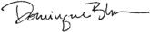

Dominique Blom,
General Deputy Assistant Secretary for Public and Indian Housing

¹⁵ https://www.hud.gov/program_offices/public_indian_housing/programs/hcv/project

Appendix I – How to Process an Over-Income Family

DETERMINATION: Determine if the family’s income exceeds the Over-Income Limit.
Step 1: Go to https://www.huduser.gov/portal/datasets/il.html and follow the instructions in Appendix II to find the Very Low Income amount for families in your jurisdiction.
Step 2: Use the following calculation to determine the Over-Income Limit: Very Low Income limit x 2.4 = Over-Income Limit
Step 3: If the family’s annual income is greater than the Over-Income Limit, then they exceed the Over-Income Limit, and must be notified up to a total of three times.
NOTIFICATION: Notify the family up to a total of 3 times that they have exceeded the Over- Income Limit.
Notice 1: Provide written notice to the OI family no later than 30 days after the PHA’s determination, stating that the family has exceeded the over-income limit.
Notice 2: If the PHA determined that the family’s income has exceeded the over-income limit for 12 consecutive months, the OI family must be provided written notice of this fact no later than 30 days after said determination.
This notice must inform the OI family that continuing to exceed the over-income limit for the next 12 consecutive months will result in the family:
  - Paying the higher alternative rent as a non-public housing over-income family; OR
  - Having their tenancy terminated.
Notice 3: If the PHA determined that the family’s income has exceeded the over-income limit for 24 consecutive months, the OI family must be provided written notice of this fact no later than 30 days after said determination.
This notice must inform the OI family that, at next lease renewal or in no more than 60 days after the date the final notice per 24 CFR 960.507(c)(3), whichever is sooner, the family must:
- Pay the higher alternative rent as a non-public housing over-income family; OR
- Be terminated from their unit in no more than 6 months. LIMITATION: After the 24 consecutive month grace period take the following actions:
- Charge as the alternative rent for the unit occupied by the NPHOI family, the greater of:

  - The applicable FMR for a dwelling unit in the same market area of the same size; or
  - The amount of the monthly subsidy which shall include any amounts from the Operating Fund and Capital Fund under section 9 used for the unit.
OR
- Terminate the tenancy of OI family in public housing not later than 6 months after the income determination confirming that the family has been over-income for 24 consecutive months.
  - Lease to convert to month-to-month term and PHAs must charge OI families, who continue to be public housing program participants, the family’s choice of income-based, flat rent, or prorated rent for mixed families during the period before termination.

Appendix II – Calculating the Over-Income Limit

Here are instructions on how to find the very low-income (VLI) limit for your jurisdiction and compute the over-income limit of a family while also providing illustrative examples related to adjustments. HUD’s income limits (IL) were developed by HUD’s Office of Policy Development and Research and are updated annually. Information about HUD’s income limits and HUD’s methodology for adjusting income limits as part of the income limit calculation can be found at: https://www.huduser.gov/portal/datasets/il.html.

Step 1: Landing Page – By clicking the link above, the landing page pictured below will populate. Then select the button titled ‘Click Here for FY20XX IL Documentation’.
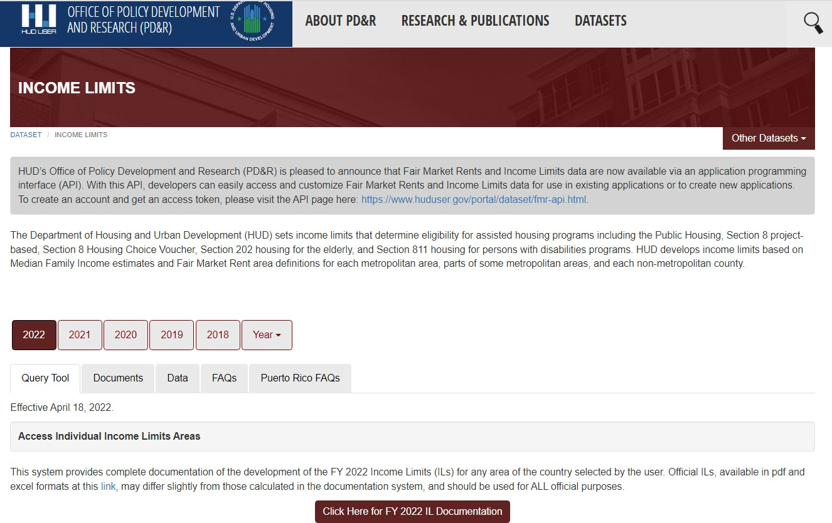
Click Here

Step 2: Select a State – Scroll down the list on the left and select the applicable state. Once a state is selected, a list of counties will appear on the right. (See step 3)
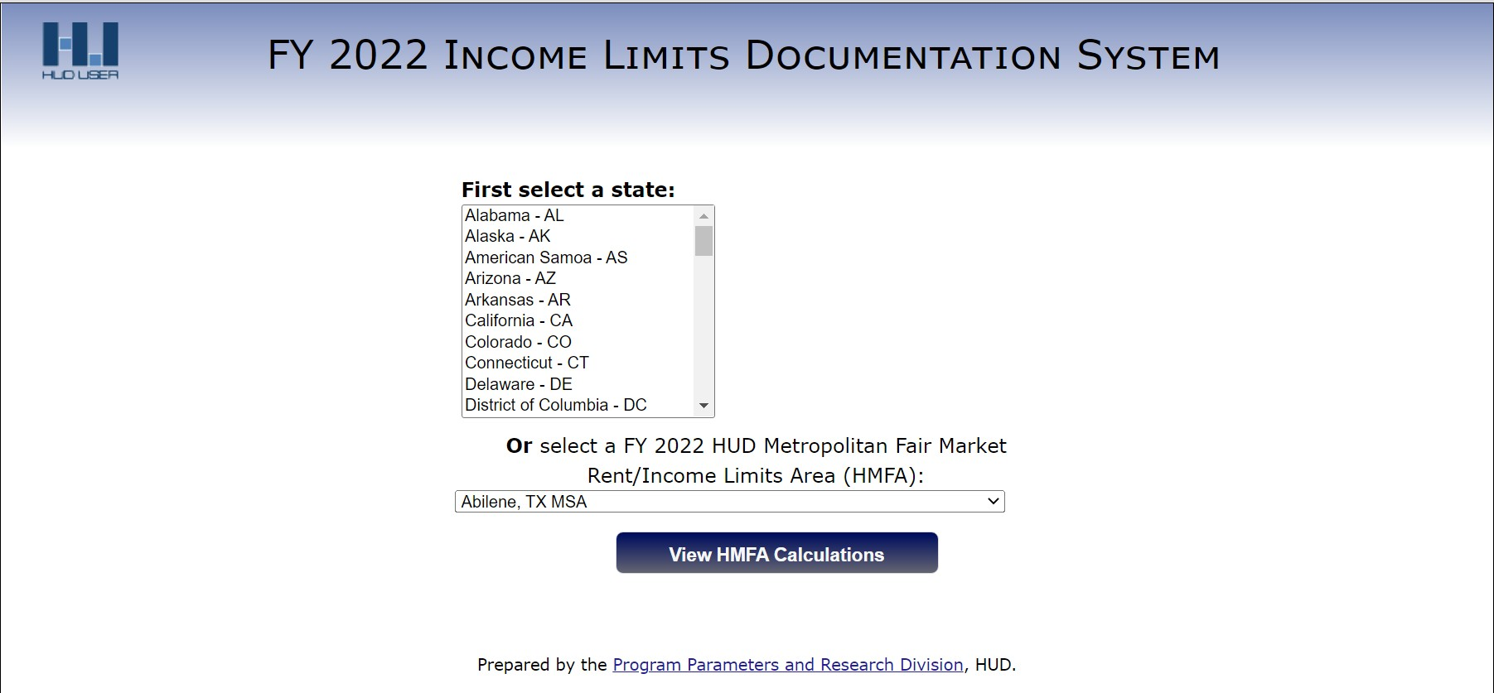

Step 3: Select a County– Scroll down the list on the right and select the applicable county. Select the ‘View County Calculations’ button.
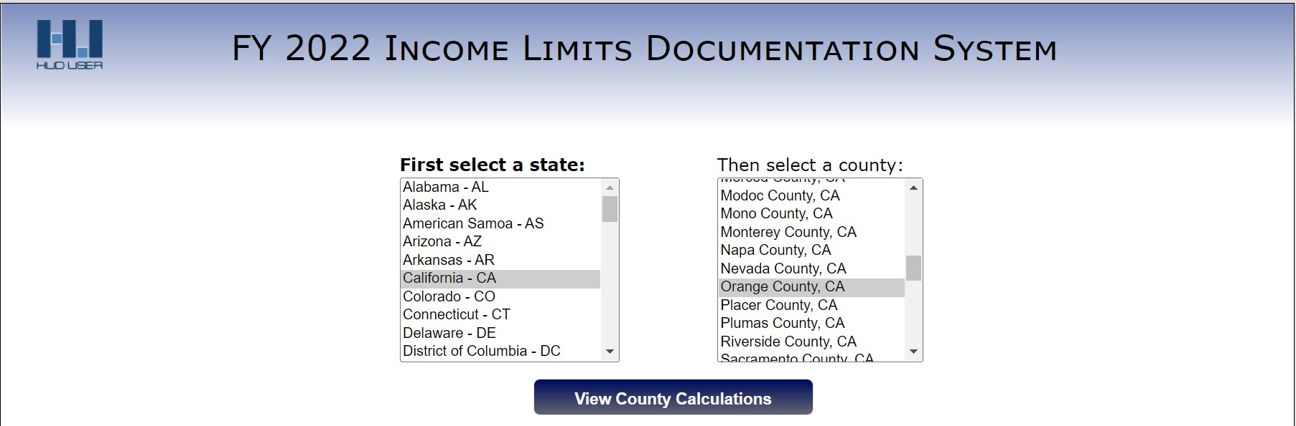
Here
Click

Step 4: View appropriate VLI Limit based on the applicable number of persons in a family.
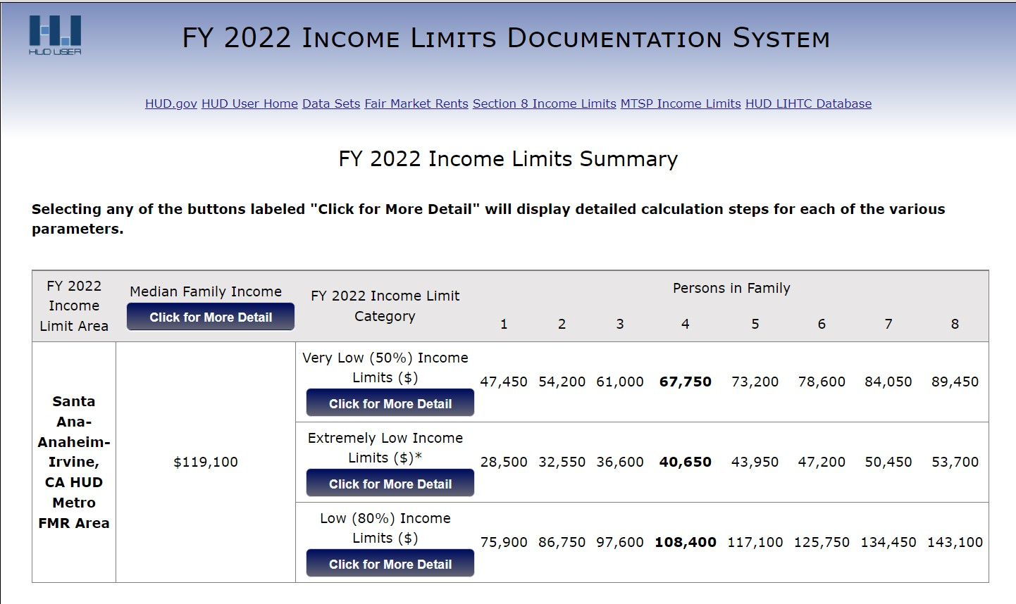
VLI

Step 5: Multiply VLI for the family by 2.4. Three examples are provided below. Note that there is an ‘explanation’ button for each income limit category that will explain what, if any, adjustments were made.
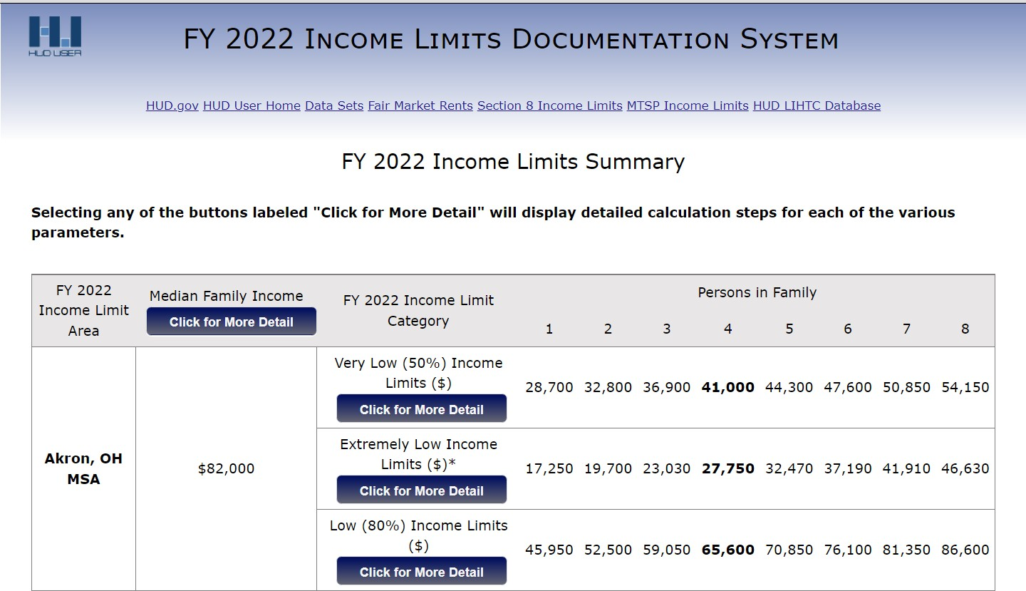Ex #1: No Housing Cost Adjustment (Summit County, Akron, OH)
For a family of 4, calculate the Over-Income Limit as follows:

$41,000 x 2.4 = $98,400

Ex #2: High Housing Cost Adjustment (Los Angeles County, Los Angeles, CA)
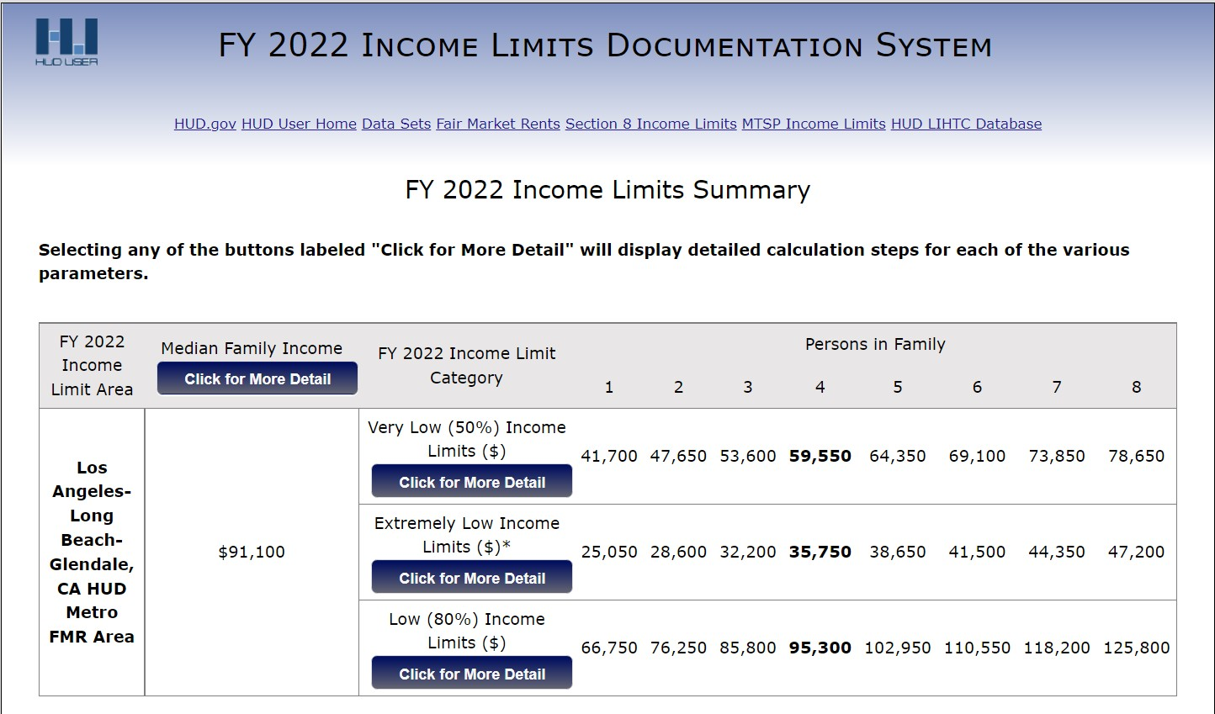
For a family of 4, calculate the Over-Income Limit as follows:

$59,550 x 2.4 = $142,920
Ex #3: Ceiling Adjustment (Jackson County, Scottsboro, AL)
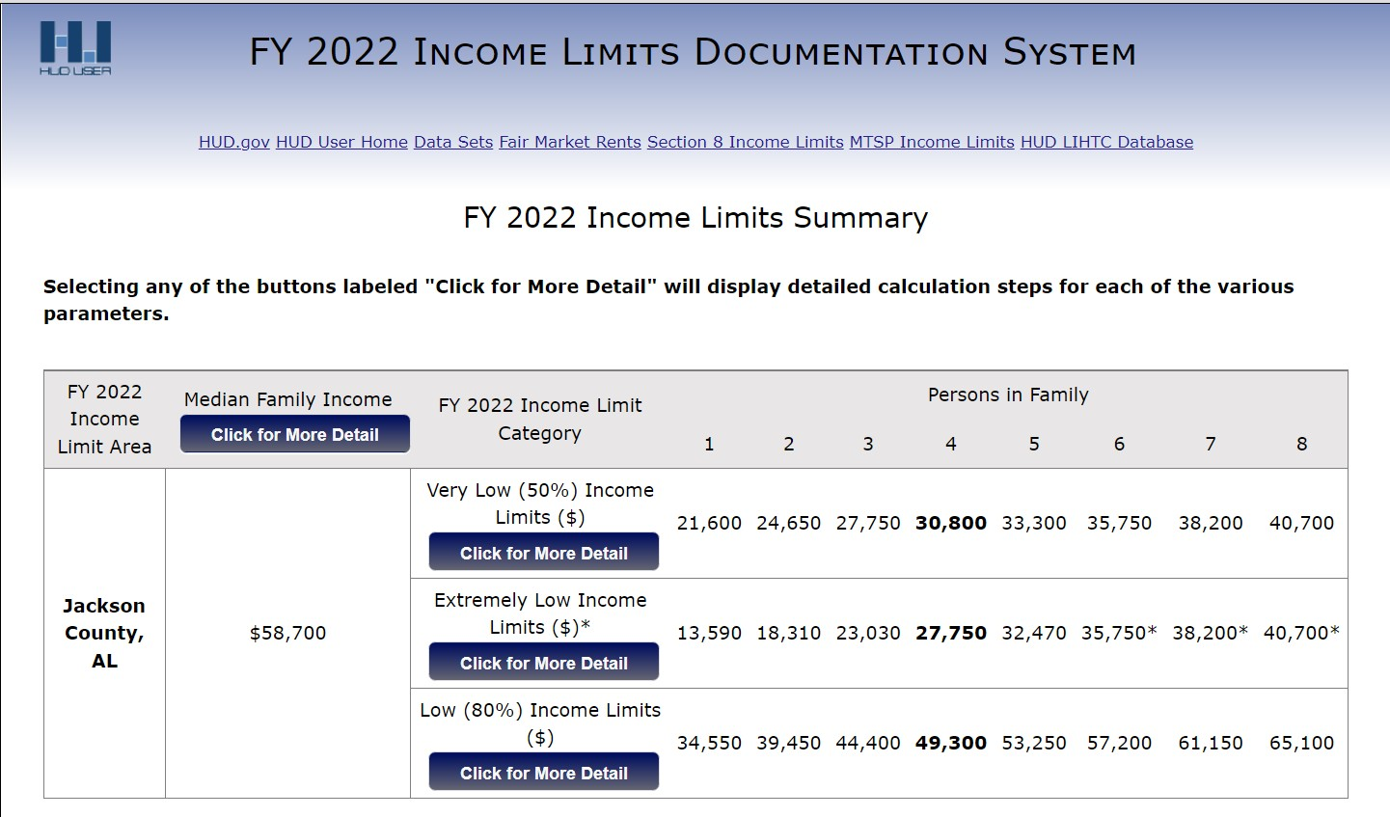
For a family of 4, calculate the Over-Income Limit as follows:
$30,800 x 2.4 = $73,920

